**INDEX**

|  |  |  |
| --- | --- | --- |
| **Sr. NO.** | **Content** | **Page No.** |
| 1. | Objective | 2 |
| 2. | References | 3 |
| 3. | Introduction | 4 |
| 4. | Test Strategy | 6 |
| 5. | Features to be tested | 9 |
| 6. | Features not to be tested | 10 |
| 7. | Item Pass/Fail Criteria | 11 |
| 8. | Test Deliverables | 12 |
| 9. | Staffing and Training Needs | 13 |
| 10. | Conclusion | 14 |

1. **Objective**

The main goal of building project is to provide a social media platform where you can contact worldwide people, chat with them, call conferencing, video conferencing, post your daily life status, discover posts, ecommerce pages, celebs, and a lot more entertainment.

As compared to traditional meetings, you can connect with anyone and track anyone’s life status in just one click.

A user friendly and attractive UI.

* Video calls with various effects and filters.
* Make, receive and manage calls.
* Posts, reels, etc.

1. **References**

* <https://ieeexplore.ieee.org/document/9457700>
* <https://ieeexplore.ieee.org/document/9535018>
* <https://developers.facebook.com/docs/commerce-platform/best-practices/test-plan/>
* <https://www.testscenario.com/social-media-apps-testing/>

1. **Introduction**

Social Media application is booming worldwide is very important in the present scenario and it performs very important role in social world and advertisement world. Using this application you can conduct calls, video calls, keep updating your life status, discover posts, reels, etc.

Instagram is a free, online photo-sharing application and social network platform that was acquired by Facebook in 2012.

Instagram was started in San Francisco by Kevin Systrom and Mike Krieger, who initially tried creating a platform similar to Foursquare but then turned their attention exclusively to photo sharing. The word Instagram is an amalgam of "instant camera" and "telegram."

Instagram allows users to edit and upload photos and short videos through a mobile [app](https://www.techtarget.com/searchmobilecomputing/definition/app). Users can add a caption to each of their posts and use hashtags and location-based geotags to index these posts and make them searchable by other users within the app. Each post by a user appears on their followers' Instagram [feeds](https://www.techtarget.com/searchcio/definition/newsfeed) and can also be viewed by the public when tagged using hashtags or geotags. Users also have the option of making their profile private so that only their followers can view their posts.

* 1. **Scope**

As with other [social networking](https://www.techtarget.com/whatis/definition/social-networking) platforms, Instagram users can [like](https://www.techtarget.com/whatis/definition/Facebook-Like-button), comment on and bookmark others' posts, as well as send private messages to their friends via the Instagram Direct feature. Photos can be shared on one or several other [social media](https://www.techtarget.com/whatis/definition/social-media) sites -- including [Twitter](https://www.techtarget.com/whatis/definition/Twitter), [Facebook](https://www.techtarget.com/whatis/definition/Facebook) and [Tumblr](https://www.techtarget.com/whatis/definition/Tumblr) -- with a single click.

Instagram is not only a tool for individuals, but also for businesses. The photo-sharing app offers companies the opportunity to start a free business account to promote their brand and products. Companies with business accounts have access to free engagement and impression metrics. According to Instagram's website, more than 1 million advertisers worldwide use Instagram to share their stories and drive business results. Additionally, 60% of people say they discover new products through the app.

Instagram provides a wide range of digital filters that can be applied to users' photos, including ones that add a vintage or faded look. Other editing features include Lux, an effect that lightens shadows, darkens highlights and increases contrast, and photo-tuning tools allow users to adjust brightness, contrast, saturation, sharpness, structure, straightness and tint. A manual tilt shift and vignette effect can also be added to photos.

In 2017, Instagram rolled out a feature that allows users to post multiple photos or videos at once, presented in a carousel format.

Taking inspiration from the popular [Snapchat](https://www.techtarget.com/searchmobilecomputing/definition/Snapchat) app, Instagram introduced a Stories feature in 2016 that allows users to share moments from their day that disappear after 24 hours. Instagram Stories includes the ability to incorporate augmented reality-based face filters and stickers, and the ability to add text, drawings, emojis, links and geotags directly to the photo or video. In April 2017, Instagram Stories recorded 200 million active users, surpassing the active users of Snapchat, its biggest rival.

Instagram also has a series of add-on apps available. These apps are Boomerang, which creates custom [GIFs](https://www.techtarget.com/whatis/definition/GIF); Hyperlapse, which creates time-lapse videos; and Layout, which creates image collages with multiple images. When installed, these apps can be accessed directly from the Instagram app.

1. **Test Strategy**
   1. **Unit Testing**

We have divided Instagram platform into small-small units, and then tested each unit one by one. Unit Testing helped us to identify very minor bugs.

(for example, Chat window, login window are some of the units)

* 1. **System and Integration testing**

**Testcases and Executions**

* Sign in/Sign out
* Home
* Messaging
* Create Post
* Profile
  + Profile
  + Saved
  + Settings
  + Logout
  1. **Performance Testing**
     1. **Memory Consumption**
* It uses 47 mb of memory.
  + 1. **Power Consumption**
* Medium Range of power consumption needed as it contains lots of operations like posts, videos, reels, etc.
  + 1. **Operations in the background**
* You can conduct/receive calls while using Instagram.
* You can do anything like switching in between apps, etc.
* Continuous refreshing is not there.
  + 1. **Memory Leakage**
* Instagram is Secured and Encrypted.
* It won’t affect the system at all.
  1. **Usability Testing**
* Testing Instagram throughout all these testing methods, we can declare that Instagram is ready to operational use.
* Instagram is user-friendly and entertainment.
  1. **Installation and Launch Testing**
* Try installing app – all the packages are installed successfully.
  + It should not affect the other apps present in the system.
* While getting an update – it successfully prevents from data loss or application crash.
* Uninstall app – while uninstalling, memory and data cache will be successfully removed from the system.
  1. **Functional Testing**
* Camera
  + Successfully able to turn camera on/off
* Microphone
  + Successfully able to turn Microphone on/off
* Chat options
  + Able to chat safely/properly person to person, in groups with various effects, stickers, gif, etc.
  1. **Secure Testing**
* Keep your account or application encrypted.
* You can put limitations to your account by giving access to world as who can see your account and who cannot by making your account from public to private.
  1. **Regression Testing**
* Whenever we encounter an update in instagram, re-execution of previous testcases had been done.
* New functionalities are also tested.

1. **Features to be tested**

Following test cases have been tested in test strategy.

* Sign in/sign out page
  + Creating new account
  + Login into existing account
* Home Page
  + Discover posts, ads like them, comment, share and save.
* Messaging
  + Like the message
  + React
  + Reply
  + GIF, themes, stickers option.
* Features – Audio/microphone/camera/chat
* Access to Account
  + Make your account public/private.
  + Create/delete a post
  + Make Reels
  + Put a Story/close-friends story
  + Change your profile image, bio.
* Log out

1. **Features not to be tested**

* Help
* COVID-19 Information Center module
* Digital Collectibles
* Archive/your activity
* Controls

1. **Item Pass/Fail Criteria:**

**Pass Criteria**

* First Module in instagram is SIGN in/Sign up page, and this module has passed all the criteria (login using existing user details, create account, login using facebook, etc.)
* Successfully able to Video call.
* Successfully able to Voice call.
* Microphone and camera options are working well.
* Successfully able to Create a post.
* Successfully able to Create a reel.
* Successfully able to Upload a Story.
* Successfully able to edit the profile.
* Able to chat with various options and filters.

**Fail Criteria:**

* Refreshing the app is little slow.

1. **Test Deliverables**
2. Requirement Document (BRS)
3. Test Plan Document
4. Input Design –
   1. ECP
   2. BVA
   3. State Transition Document
5. Test Scenario
6. Test Case Writing Document
7. Test Case Execution Document
8. Execution Log
9. Defect Report
10. **Staffing and Training needs**

Staffing

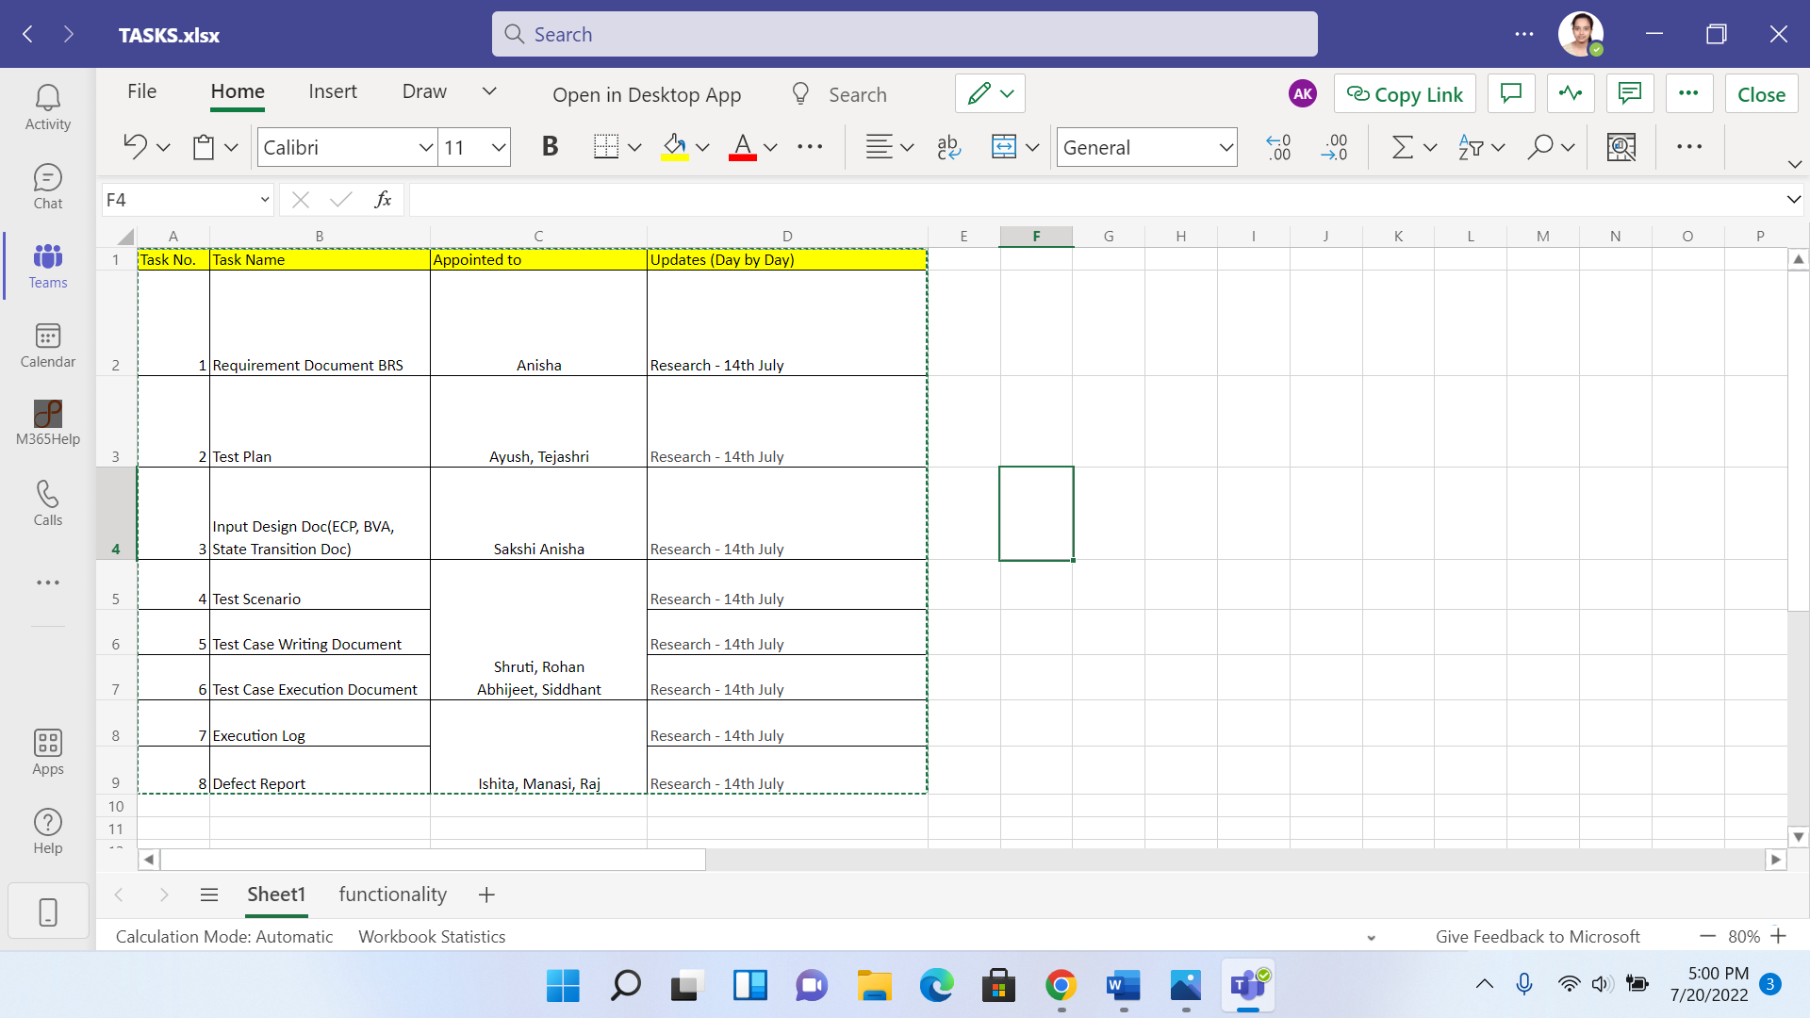

Training Needs

* INSTAGRAM is user-friendly.
* Basic training can be taken.
* Give training on tools of INSTAGRAM which are facilitated for host.

1. **Conclusion**

After testing the application through all the methodologies, strategies here we conclude that INSTAGRAM is ready for operational use.